Voice Deal - Home



COLT48 Voice Deal 48
- ZERO charge on TM Fixed Line rental
- FREE calls to TM Fixed Line nationwide
- FREE minutes for calls to mobile (depending on the package subscribed)
RM48.00


COLT68 Voice Deal 68
- ZERO charge on TM Fixed Line rental
- FREE calls to TM Fixed Line nationwide
- FREE minutes for calls to mobile (depending on the package subscribed)
RM68.00

Voice Deal – Business

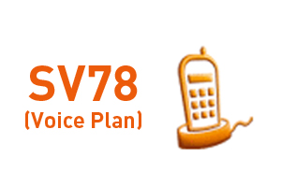

Telephony - Business Line
RM78.00

Telephony - Business Line
RM78.00
Features & Benefits:
FREE monthly line rental
FREE DECT Phone
Low monthly commitment fee of RM78
Low rates for call beyond the free usage
5% discount on monthly commitment fee from the 13th months onwards.
Rates:
Monthly Commitment Fee
RM78
Free Usage
RM88 worth of call value at normal rates
Beyond Call Rates
Local - 4sen/min
Fixed line to fixed line (national) - 10sen/min
Fixed line to mobile - 15sen/min

